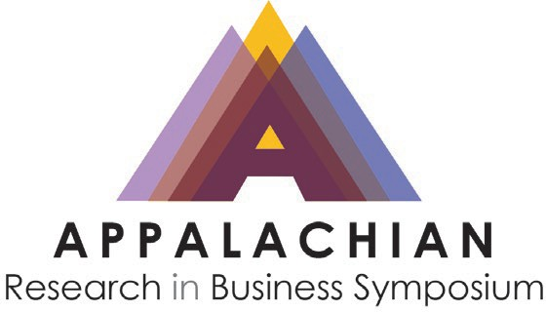
Call for Papers
Appalachian Research in Business Symposium Hosted by Marshall University
March 27-28, 2025

You are invited to submit your research to the 2025 Appalachian Research in Business Symposium (ARBS) to be held on March 27-28, 2025, at the Marshall University Lewis College of Business located in Huntington, WV. This year’s symposium will be hosted on-site by Lewis College of Business at Marshall University. Participants will find opportunities for presenting new research, discovering contemporary ideas, and building connections. A welcome reception will be held on the evening of Thursday, March 27th, and the presentations will be held on Friday, March 28th. The registration fee for the conference is $100. We are pleased to also offer a discounted rate of $30 for student registration.

Submissions are encouraged from scholars who use different theoretical and empirical approaches to deliver the latest research results in different business fields (e.g., Accounting, Data Analytics, Business Education, Computer Information Systems, Communication, Supply Chain Management, Economics, Entrepreneurship, Finance, Hospitality and Tourism, Management, Marketing, Risk Management, Insurance, International Business, Technology/Information Systems, Business Law, Sports Management, Project Management, Healthcare Management and similar disciplines).

Guidelines for Submitting Your Research:
Submissions will be peer-reviewed for acceptance at ARBS 2025, and at least one author from each accepted submission is required to register for the conference and present the research. There are two options for submission:

Short Paper Submission: Submissions should have approximately 750-2000 words. Accepted short papers will be published in the ARBS 2025 proceedings, unless the author requests otherwise. All submissions are required to be formatted to the specifications of the template found HERE. Please submit your short paper as a Microsoft Word document to Yemba@marshall.edu.

Abstract Submission: Submissions should have approximately 300-500 words. Abstracts will not be included in the proceedings. All submissions are required to be formatted to the specifications of the template found HERE. Please submit your research proposal as a Microsoft Word document to Yemba@marshall.edu.

Important Dates:
Submission deadline: February 1st, 2025
Author notification of accepted manuscripts/presentations: February 15th, 2025
All information will be available on the conference website:
https://www.marshall.edu/cob/arbs-2024/

Conference Committee:

Affiliation | Representative | Email
Marshall University | Boniface Yemba (conference chair) | yemba@marshall.edu
Eastern Kentucky University | Julia Graham | julia.graham@eku.edu
Appalachian State University | Jason Xiong and Tanga Mohr | xiongjj@appstate.edu and  mohrtm1@appstate.edu
East Tennessee State University | Prasun Bhattacharjee | bhattacp@etsu.edu
Radford University | Zachary A. Collier | zcollier@radford.edu
Western Carolina University | Ethan Cheng | ycheng@email.wcu.edu

We look forward to receiving your submissions!

