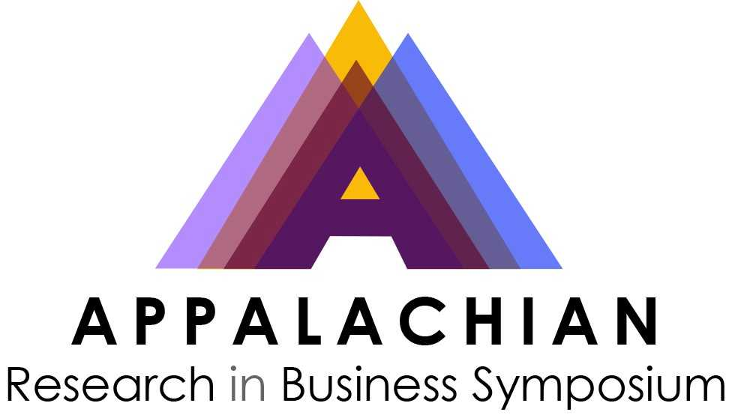
ARBS Conference Hotels:

- Delta Hotels by Marriott
800 3rd Avenue
Huntington, West Virginia 25755
Room Block Code:
Room Rate: $129 Thursday night (3/27/25) and Friday night (3/28/25)
To book your room, please call 304-523-8880 or click here Book your group rate for
Appalachian Research in Business Symposium

- DoubleTree by Hilton Huntington
1001 3rd Ave, Huntington, WV 25701
Reservations for the Event will be made by individual attendees directly with reservations at (304) 525-1001.
Room Rate: $129 Thursday night (3/27/25) and Friday night (3/28/25)
NAME OF EVENT: Appalachian Regional Business Symposium - ARBS
REFERENCE #: M-U8QYAAC
OFFICIAL PROGRAM DATES: Thursday, 03/27/2025 - Friday, 03/28/2025

