
Employer Interviews
Spring 2024
CAEP R4: Program Impact (R4.2, R4.3)

Evidence Name: 4.1.2_EmployerInterviews

Description: In March 2024, the College of Education and Professional Development (COEPD) invited principals from West Virginia, Ohio, and Kentucky who had employed recent COEPD graduates (within their first three years of teaching) to participate in a ten-minute interview regarding their level of satisfaction with these completers. The interviews were conducted between April 22 and May 10, 2024, and participants were entered into a drawing for a $25 Marshall University Bookstore gift card as a token of appreciation. A total of 14 principals participated in the interviews, providing feedback on the following questions:

Interview Questions:
- How would you describe the overall Level of Preparation of our completers for the assigned responsibilities as a teacher? Do you believe graduates were deficient in any teaching areas?
- What are the strengths and weaknesses of the training our graduates received from the COEPD?
- How would you describe the graduates preparation with understanding, using, and communicating about using data to make informed decisions? (i.e.: Do they conference with parents/guardians? Do they work with parents/guardians and child when making decisions? Do they review child’s records or other sources of information when making decisions?)
- How would you describe our graduates preparation to use quantitative, qualitative, or mixed-methods research methods?
- How would you describe our graduates preparation to use data to develop supportive, diverse, equitable, and inclusive school environments?
- How would you describe the graduates preparation to lead or participate in collaborative activities?
- How would you describe the graduates preparation to Incorporate and Use Technology in the classroom or with assigned activities?
- How would you describe the graduates preparation to apply professional dispositions, ethics, or professional standards?
- Would you continue to employ our graduates and why?

Example Invitation Emailed to Principals
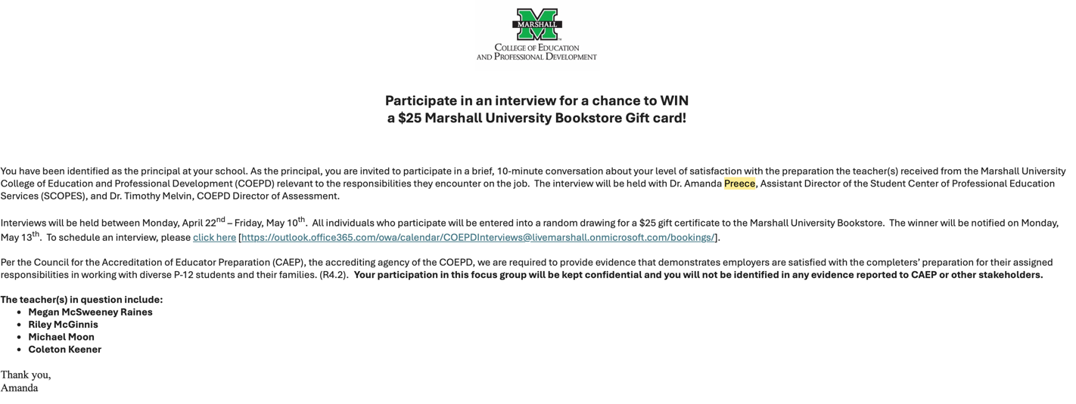

Summary of Responses:

The principals expressed general satisfaction with the preparedness and performance of recent graduates, noting several areas where they exceeded expectations. Many described the graduates as well-prepared, particularly in instructional design, lesson planning, and collaboration with colleagues. They commended their ability to create engaging and meaningful lessons, their strong communication skills, and their professionalism. Principals were especially pleased with the graduates' ethical standards and their ability to maintain respectful, professional relationships with students, parents, and colleagues. Additionally, the graduates’ enthusiasm, adaptability, and eagerness to learn were frequently highlighted as qualities that made them valuable members of school teams. Satisfaction from principals was also high regarding the ability for COEPD graduates to analyze and use data to inform instruction, with principals noting that graduates were capable of identifying trends and adjusting teaching strategies effectively. Furthermore, many principals recognized their growing comfort with integrating technology into their teaching, with some even demonstrating creative and innovative approaches to using digital tools.
Despite the overall satisfaction, areas where graduates could improve to enhance their readiness and effectiveness were identified by some principals. Classroom and behavior management emerged as a common concern, particularly in managing diverse or high-need classrooms and addressing challenging student behaviors. While the graduates demonstrated a solid grasp of instructional strategies, their ability to differentiate instruction to meet the needs of all learners, especially students with exceptionalities, was identified as an area for growth. Satisfaction with their understanding of data use was somewhat tempered by the observation that many graduates needed additional practice in effectively communicating data insights with parents or using data to make concrete, actionable decisions. Principals also noted that, while the graduates had a basic understanding of research methods, they often struggled to apply these methods in real-world classroom scenarios, which limited their ability to address instructional challenges effectively.

Satisfaction was mixed regarding technology integration. While many graduates were comfortable with basic tools like Google Classroom and PowerPoint, some hesitated to explore more advanced applications or struggled to adapt technology to meet the needs of diverse learners. Principals expressed a desire to see graduates more confidently integrate technology in meaningful ways that enhance student learning. Similarly, while the graduates excelled in collaborative activities, there was room for growth in their ability to take on leadership roles within teams. Principals felt that graduates were strong team players but were less confident in initiating or leading group efforts. While their professionalism and ethical standards were consistently praised, some principals suggested that additional exposure to real-world situations, such as handling sensitive parent interactions or navigating complex student needs, would help graduates build confidence and refine their professional dispositions.

Overall, the principals conveyed satisfaction with the graduates’ preparedness and performance, appreciating their contributions to their schools while offering constructive feedback on areas where they could further develop. While the graduates are seen as strong, capable educators, addressing these areas for growth will help ensure they are even better equipped to meet the demands of today’s classrooms.

