The Fund Dashboard tab provides a Quick Look financial overview of a single Sponsored fund.
Using the Quick Look
- With the Quick Look box open, select an active Sponsored fund from the drop-down menu options.
Please note: The selection of funds is based on user’s Chartstring Security access. Please consult with your Fund Manager Administrator with access questions.
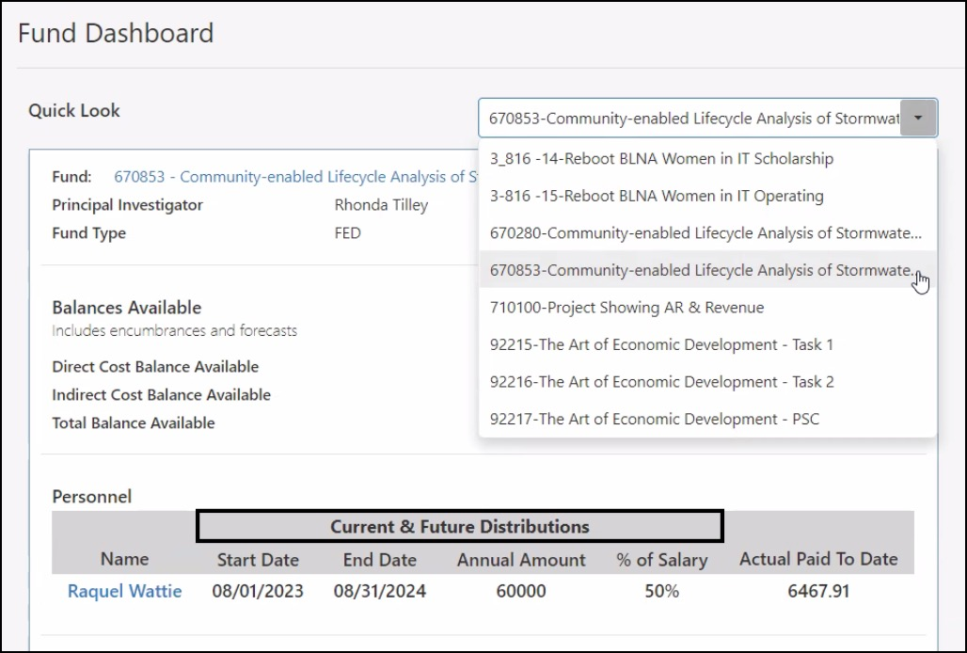
- The following information will populate:
  - Fund information: Populated from Fund Code Table. The Fund hyperlink routes you to Fund Balance by Object Code Summary page.
  - Balances Available: Displays real-time balances, including encumbrances and forecasts.
  - Personnel Data: See below
  - Expenditure Burn Rate calculations: See below
Understanding Personnel Data
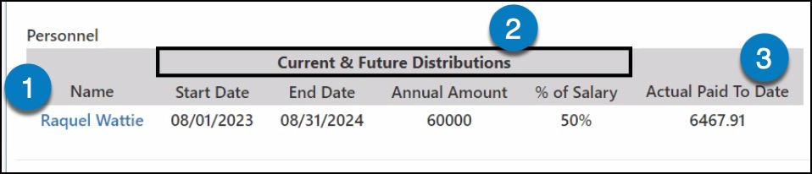
- Name: Employee name is populated from the employee ID in the Personnel page.
- Current & Future Distributions: This data populates from the Personnel Salary Distribution page. It will only display data if an employee has a current or future distribution allocated to the fund selected. It will not display any historical distributions that have ended.
- Actual Paid To Date: The total of all actual payroll expense transactions posted to a Salary Object code for the fund selected. These transactions must have a RefNum1 equal to a person's employee ID number in order to populate accurately.
Understanding Expenditure Burn Rate Calculations
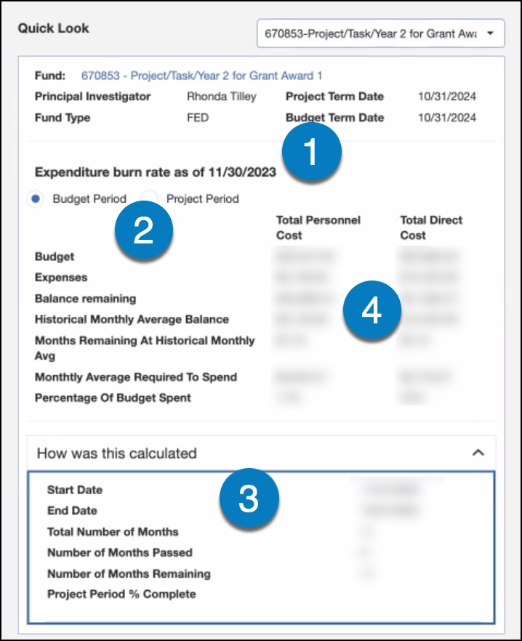
- Expenditure burn rate date: The date and calculations are based on the prior month-end.
- Budget or Project Period: Calculations can be determined based upon either the Budget Period or the Project Period dates that are associated to a Fund in the Fund Code table. Upon selecting a fund, the default is set to the Budget Period date but can be updated by selecting the Project Period radio button.
- How was this calculated:
  - Start and End Dates - are populated from the Fund Code table, based upon the selection of Project Period or Budget Period.
  - Total Number of Months - within period is displayed.
  - Total Number of Months Passed - indicates the number of months that has been completed within the period selected.
  - Number of months remaining - indicates the remaining months from now until the end date.
  - Project Period % Complete - this calculation equals the number of total months passed, divided by the total number of months.
- Expenditure Burn Rate Calculations: The figures in this section are calculated utilizing the information in the How was this calculated section.
  - Total Personnel Cost Column - displays the amounts below, using only Salary and Fringe Object Codes.
  - Total Direct Cost Column - displays amounts below using only Salary, Fringe, Non-Personnel, and Restricted Object Codes.
  - Calculations are determined based upon the Transaction Date for budgets and actual expense transactions only. Only the Transactions posted between the start and end date of the period selected will be included in the amounts below:
    - Budget - Total of all Budget Transactions posted to the allocated object codes within the period selected
    - Expenses - Total of all Actual Expense Transactions to the allocated object codes within the period selected
    - Balance remaining - Equals Budget less Expenses
    - Historical Monthly Average Balance - Equals Expenses/Number of Months Passed
    - Months Remaining at Historical Monthly Avg - Equals Balance Remaining/Historical Monthly Average Balance. This will provide you with the number of months it will take before you are out of funding if you continue to spend in the future as you have on average in the past.
    - Monthly Average Required to Spend - Equals Balance Remaining/Number of Months Remaining. This will provide you with the average monthly amount you would need to spend in the future to utilize all the funding by the end date.
    - Percentage Of Budget Spent - Equals the Total Expenses/Total Budget. Use this percentage to compare to the Project period % complete to analyze the spending pattern.

