Cayuse Fund Manager in-app reporting allows you to create, save and export custom reports depending on your needs.
Please Note: You will only be able to access data that you've been given permission to access. For questions about your account permissions, please contact your Administrator.
Report Dashboard
All users can access the Reporting tab from the Fund Manager home page.
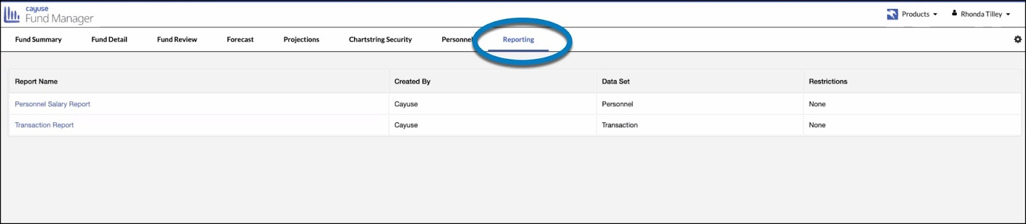
Select the type of report you would like to generate:
- Personnel Salary Report (requires Salary Access role)
- Transaction Report (all roles)
You will be taken to the report dashboard for the selected report. You will be taken to the report dashboard for the selected report.
- The Personnel Salary Report will automatically return results of all the personnel that a user has access to see.
- The Transaction Report requires that you select:
  - Date type (Transaction or Accounting)
  - Start and end dates
  - Optional: Select a Principal Investor and/or Fund Number
  - Select Go
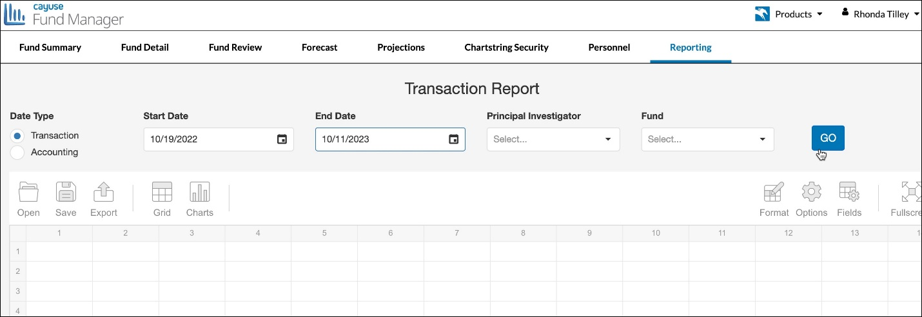
Default Fields
When the report is generated, default fields will automatically populate with data available from the fields in your form and in your specific environment. In addition to the default fields, you can add more fields using the Fields functionality (discussed below).
Default Fields in Transaction Report | Default Fields in Personnel Salary Report
Transaction Type Code | Personnel Identifier
Ref Num 1 | Person Name
Ref Num 2 | Personnel Type Code
Description | Title Description
Fund Code | FTE
Cost Center Code | Distribution Start Date
Object Code | Distribution End Date
Object Code Name | Actual Salary For Forecasting
Transaction Date | Benefits Package Name
AmountX (Actual) | Pay Type Code
AmountE (Encumbrance) | Person Pay Period Type Code
AmountB (Budget) | Salary Start Date
Fund Name | Salary End Date
Fund Type Name | Fund Code
Parent Fund Type | Fund Name
Fund Status | Object Code
Budget Start Date | Cost Center Code
Budget End Date | Cost Center Name
Principal Investigator | Cost Share Fund Code
Fund Org Code | Annualized Salary Distribution Rate
Cost Center Name | Percent of Distribution
 | Principal Investigator
 | Fund Responsible Name
Modifying Report View
Each of the default reports have the same dashboard tools, allowing the view to be modified. However, there are some differences between the two reports.
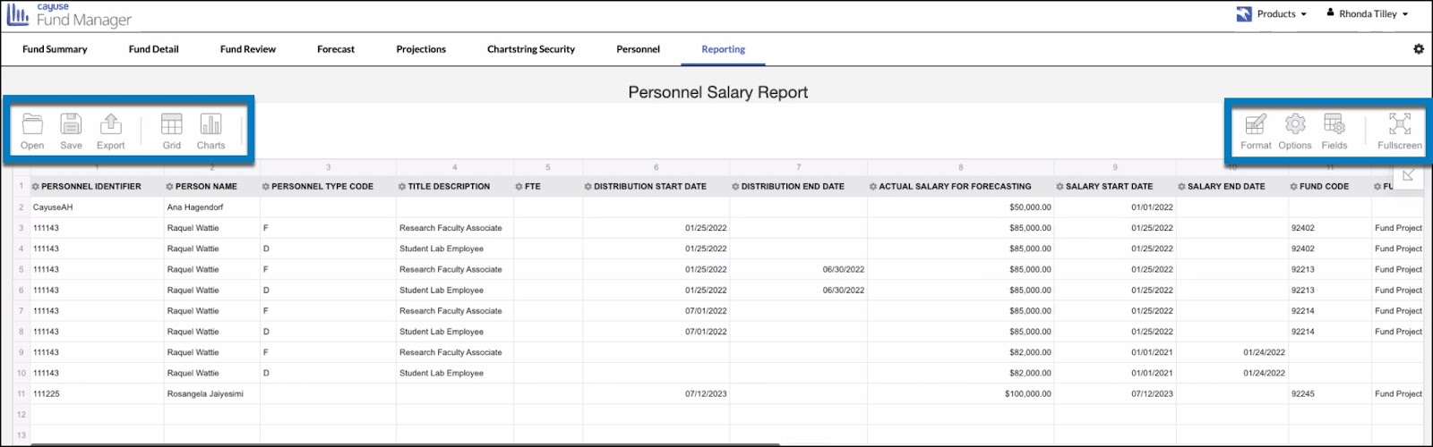
- Open
- Save
- Export
- Grid
- Charts
- Format
- Options
- Fields
- Fullscreen
Overview of Tools
Open
Open your saved work (see below), format, and layout using the previously downloaded .json file.
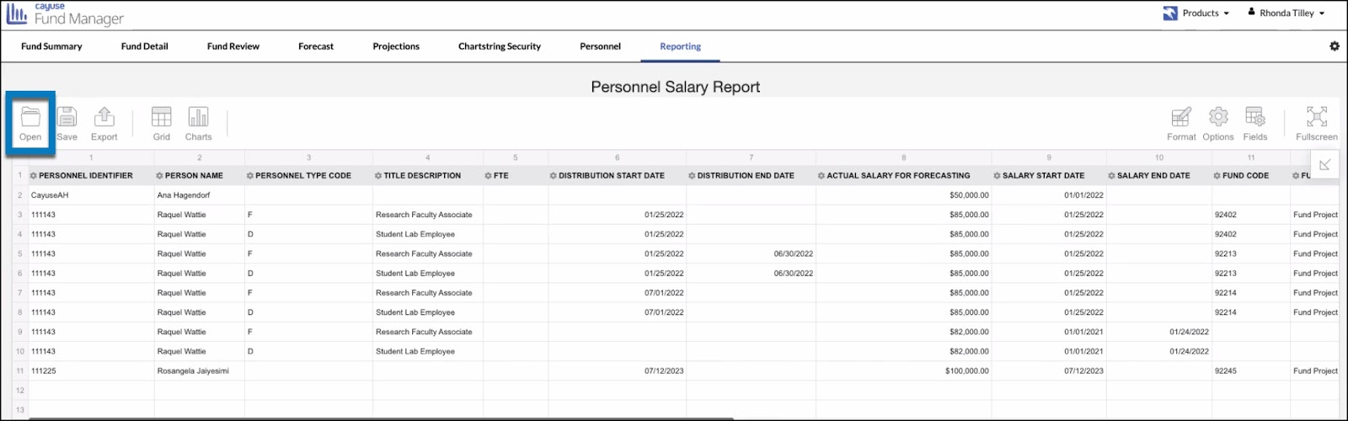
- Hover your mouse over the Open button, and select Local report.
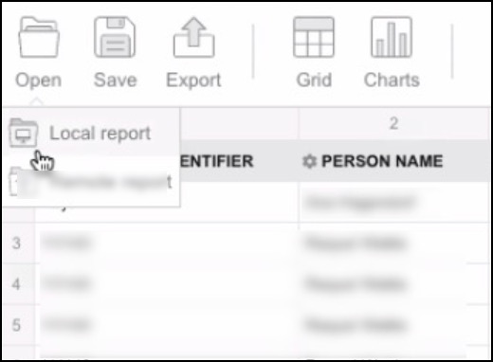
- Double-click on the .json file you wish to open.
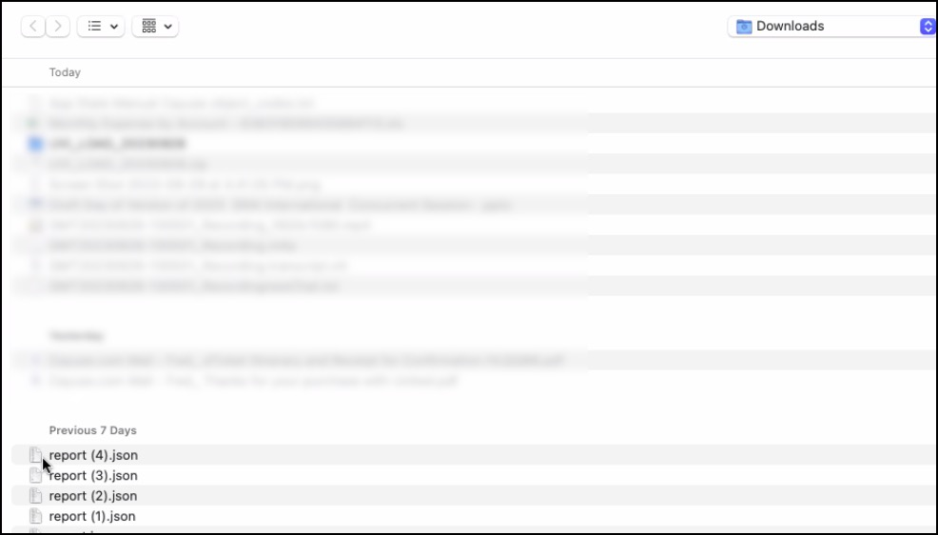
Your saved file will display in the Transaction Report Grid.
Save
Once you have modified your report, you will save it in the default .json file. The .json file will save your format only (not the data) to ensure your format is preserved for future use. The file will download to your device so that you can upload it in the future, using the Open feature discussed below.
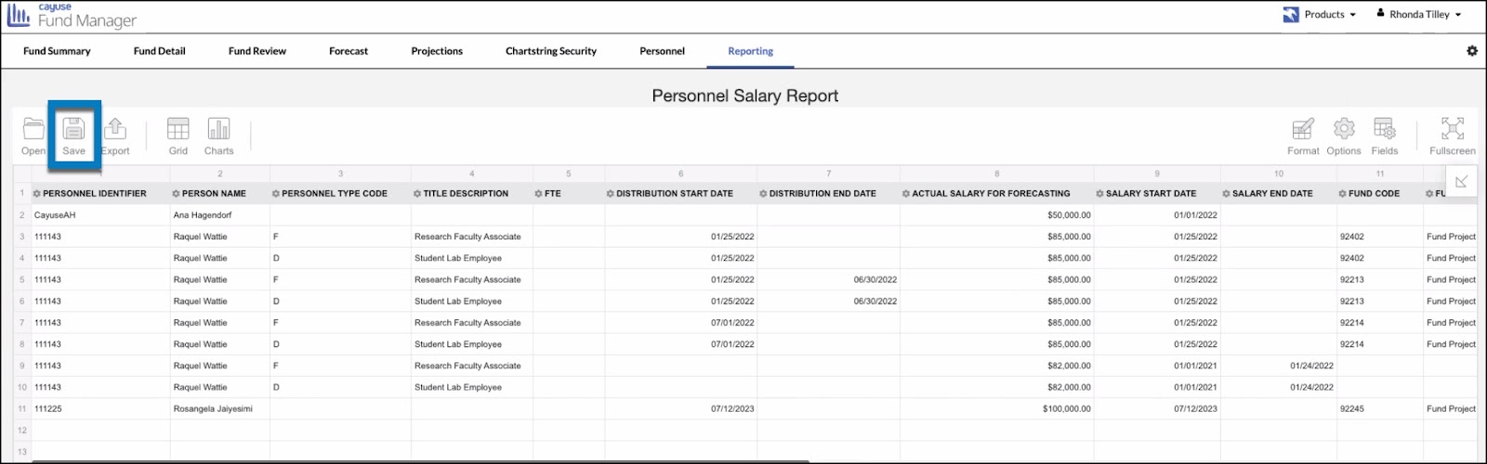
- Click the Save button.
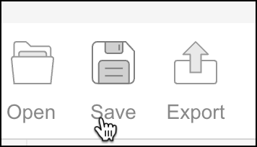
- Click Save to confirm you would like to save the file.
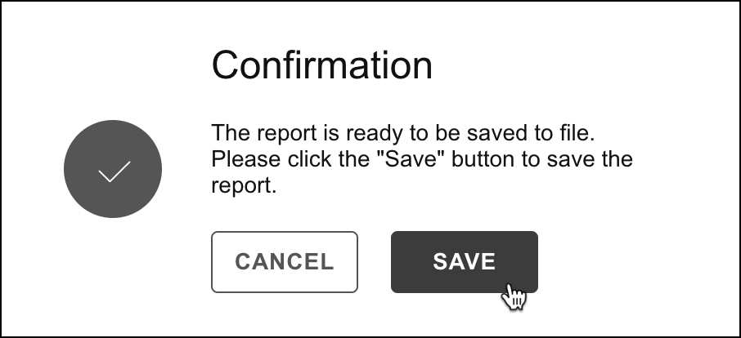
The .json file will download to your device and can be used at a later time by utilizing the Open button (see above).
Export
Export your report data to various formats (print, HTML, CSV, Excel, Image, PDF) for saving or sharing.
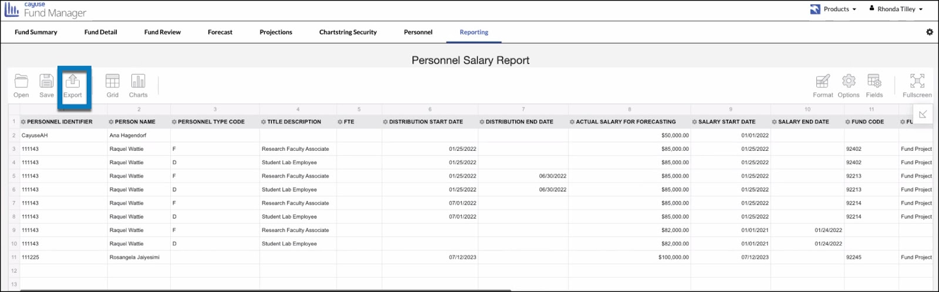
- Hover your mouse over the Export button. Select the desired export format. The file will download to your device.
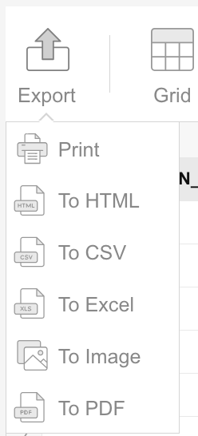
Grid
Click on Grid to return to the original column view.
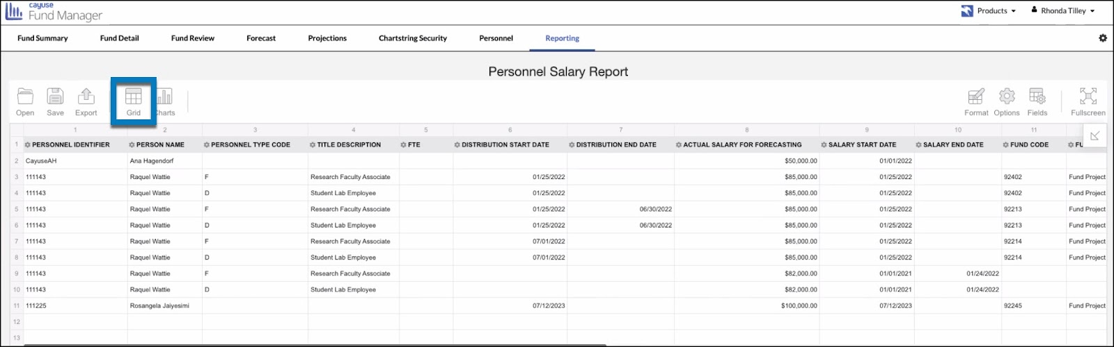
Charts
Create a chart utilizing the data in the grid to provide a visual display of the financial data.

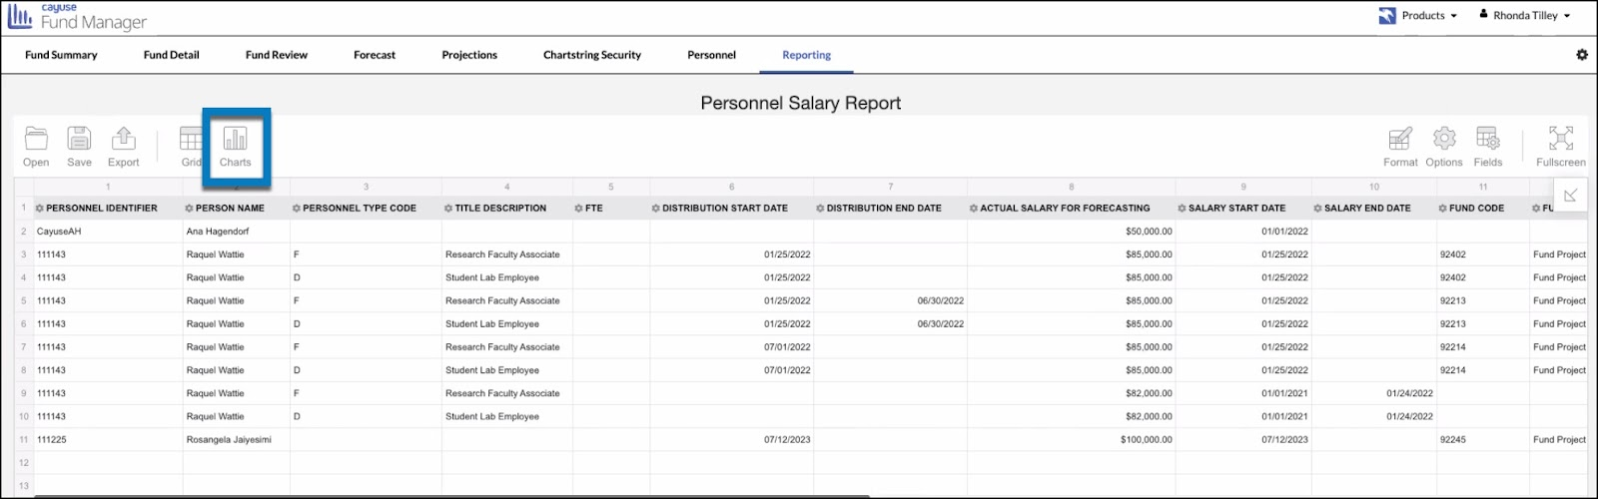
- Hover your mouse over the Charts button. Select the desired chart format.
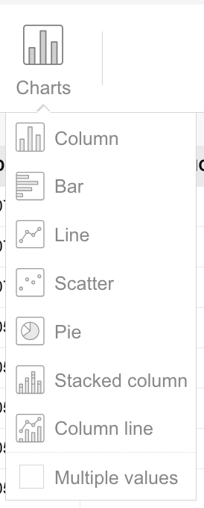
- After selecting the chart format, click on the Fields button in the tools dashboard. From here, drag and drop the fields you wish to display in the chart. Click Apply.
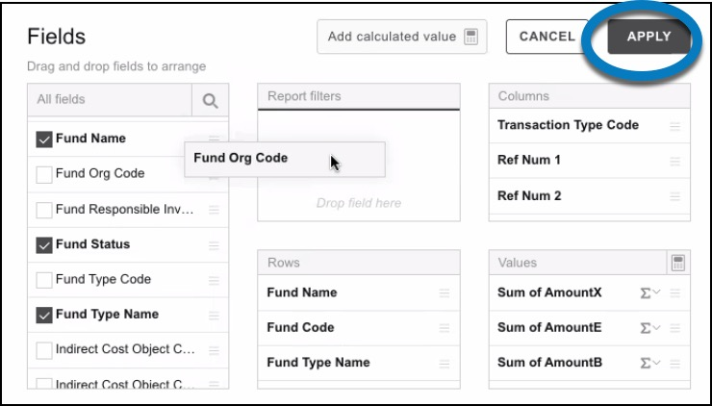
Format
Format cells or apply conditional formatting in specific columns.
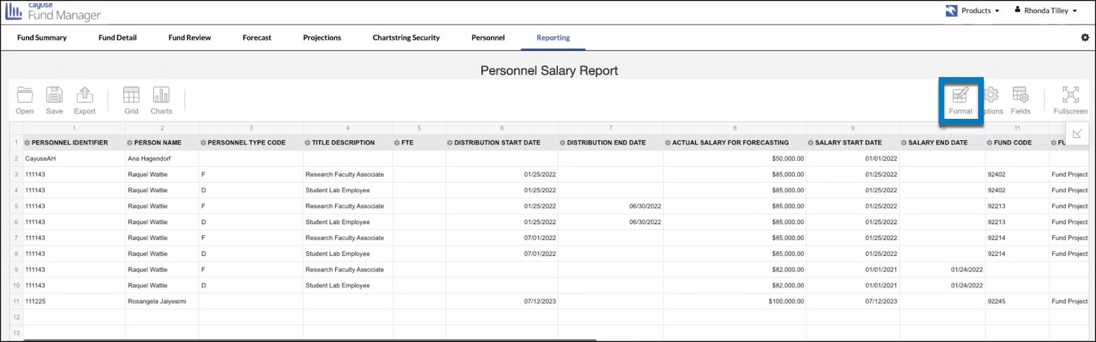
Format Cells
- Hover your mouse over the Format button. Select Format Cells.
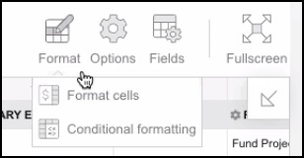
- In the CHOOSE VALUE row, select the name of the column you want to format.
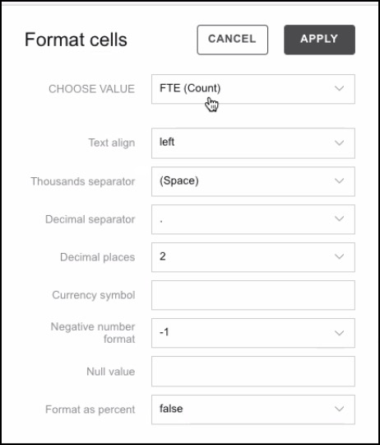
- Update the formatting using the drop-down menu. Click Apply.
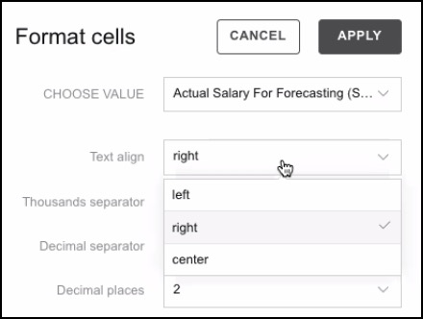
The column will be displayed using the updated format settings.
Conditional Formatting
Conditional formatting allows you to change the appearance of cells on the basis of conditions that you specify.
- Hover your mouse over the Format button. Select Conditional Formatting.
- Click Add Condition.
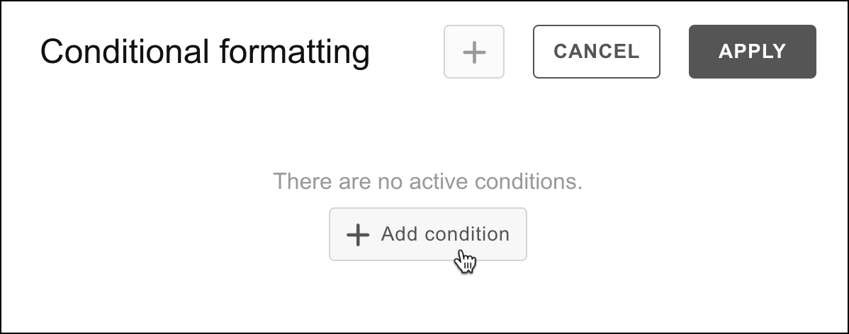
- Specify the conditions you want to apply. Click on Apply. To add more conditions, click on the plus sign.
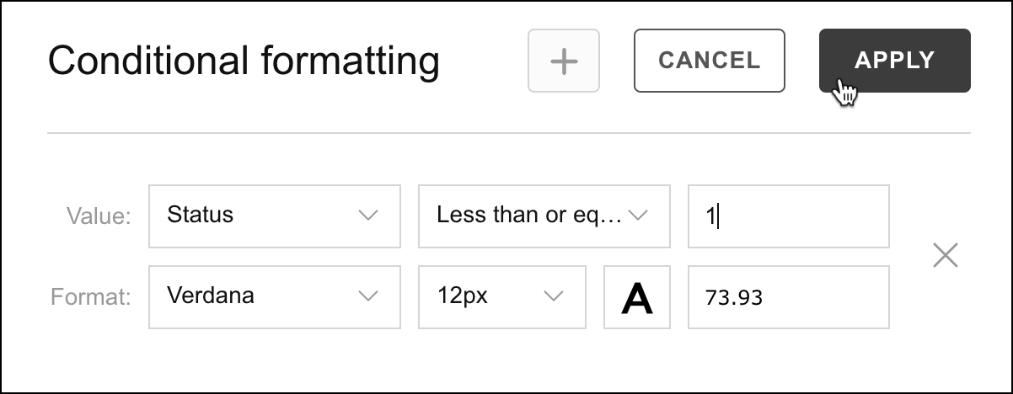
The columns specified will update to display the selected conditional formatting.
Options
Select different layout options for Grand Total, Subtotal, and Layout.
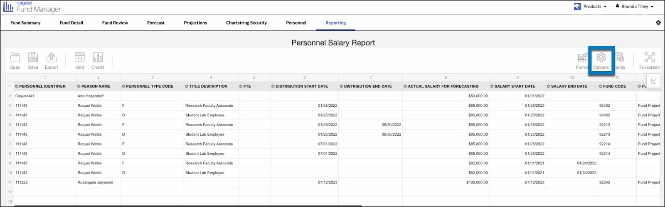
- Hover your mouse over the Options button. Make desired changes and selections. Click Apply.
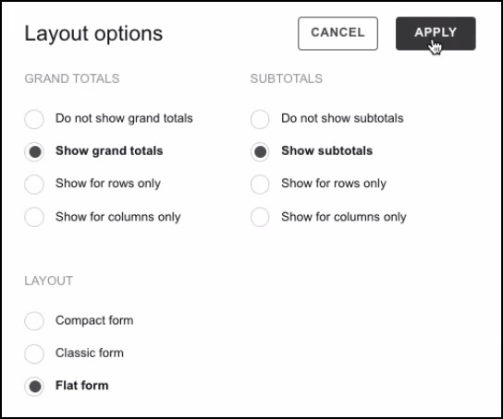
Fields
Choose from all form objects that exist to select and arrange columns within your report.
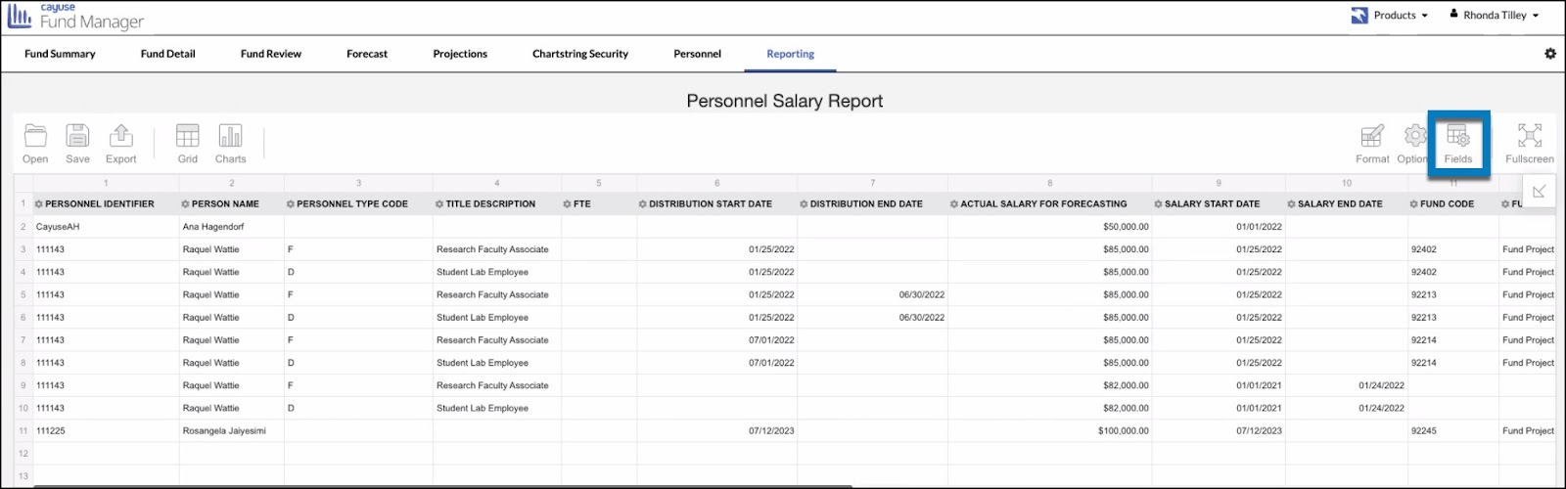
- When you click on Fields, You will see a comprehensive list of all fields availableto retrieve in a specific report. Check any boxes that you want displayed in your report. Uncheck any boxes you wish to remove from your report. Click Apply.
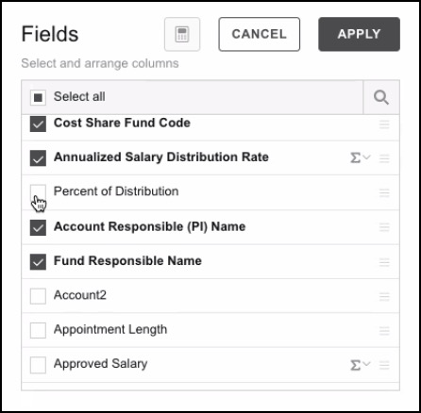
- If you wish to rearrange the columns, drag the button to the right of the column name (the three hamburger lines) to the preferred location within the report. Click Apply.
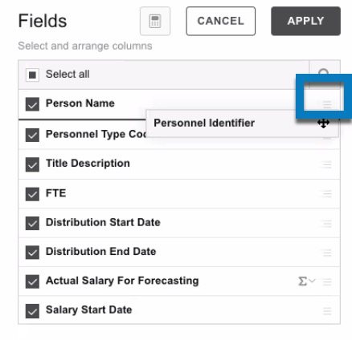
Your rearranged and updated columns will now be displayed.
You can also drag and drop columns and resize them from directly inside the grid.
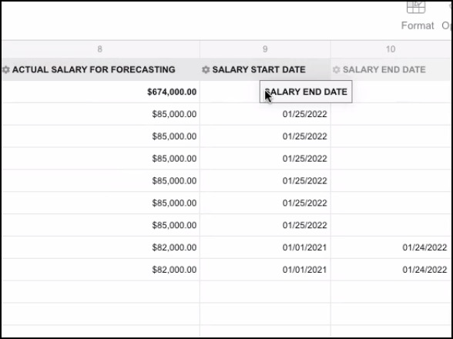
Fullscreen
Click on Fullscreen to enlarge your report to the full size of your screen. Click on Minimize to reduce the size.
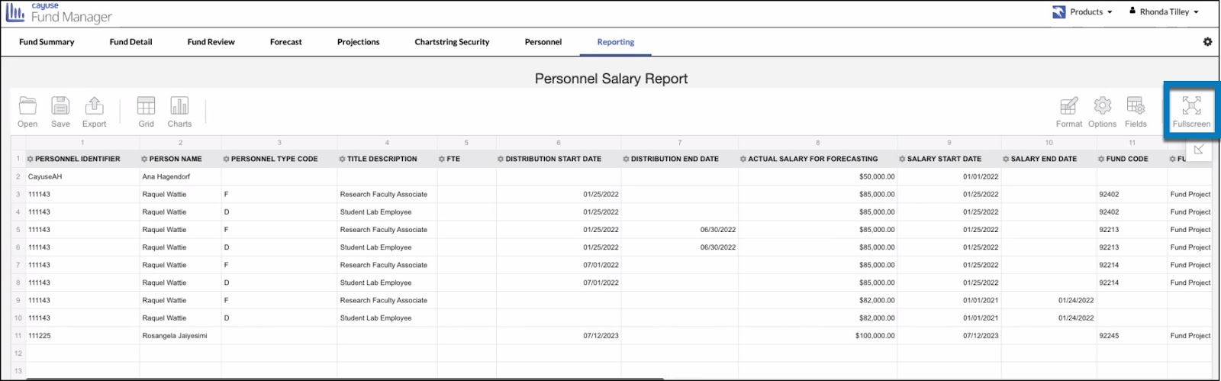
Sort
Columns can be sorted in ascending or descending order.
- Hover your mouse over the column name (ex: Cost Center Code). An arrow will appear to the right of the column name.
- Click the arrow up or down arrow to sort in ascending or descending order.
- 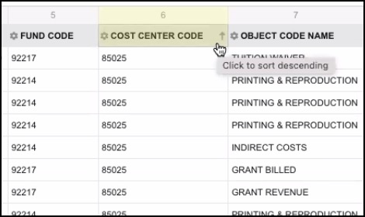
Your sorted data will appear in the order selected.
Filter
Select specific data to view within columns.
- Click the small settings wheel located to the left of the column name.
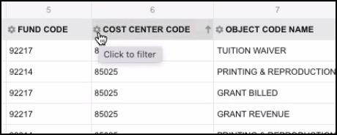
- Check one or more boxes for the desired filters, then click Apply.
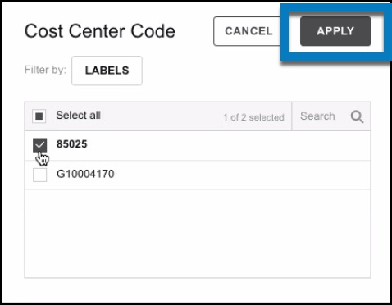
Your report will now display results matching your filter.
To modify the filter, click on the funnel icon to the right of the column name.
