Viewing Sponsored Fund Details
Once you have added Funds, navigate to the Fund Detail tab. Then, click on the Sponsored Funds sub-tab to view details.
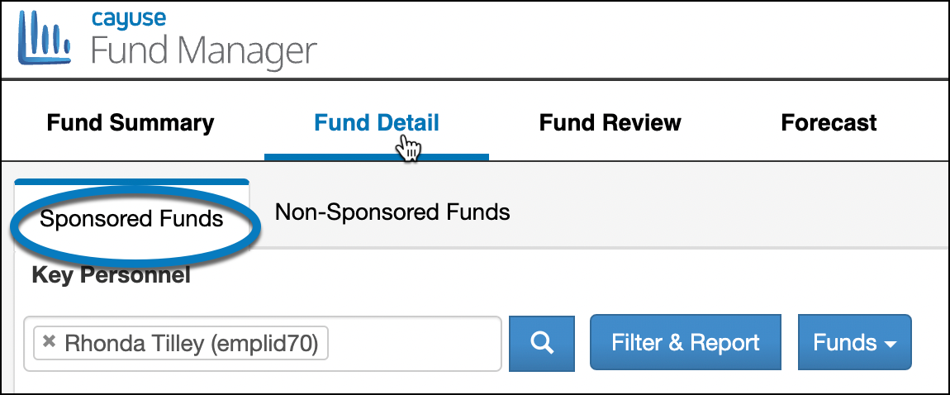
The Sponsored Funds detail shows the Funds that are assigned to a Fund Type Code in the Master Fund Table that has a Parent Fund Type of Sponsored.
If that Fund has a Fund Type Code with a parent of Non-Sponsored, then click the Non-Sponsored sub-tab to review those funds.
Sponsored Funds Overview
The funds in this view are displayed in a Budget Based View.
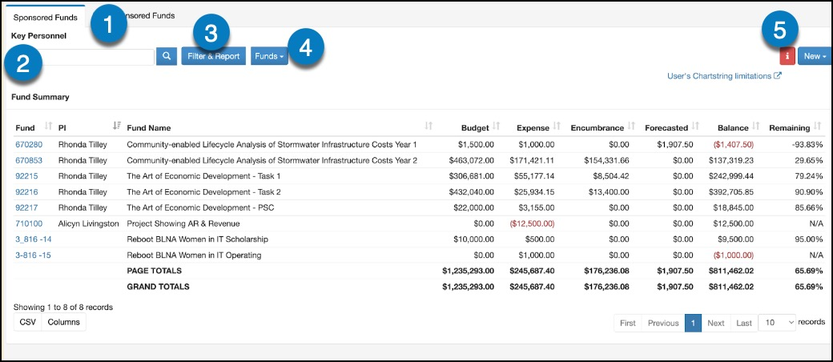
- Sponsored Funds Tab: Indicates you are viewing funds that came from this type of grant funding
- Key Personnel Search Bar: Enter a name to search for funding by personnel. Then click on the magnifying glass to load results
- Filter & Report: Open the access additional filters for your search
- Funds: Select the type of fund to search by: Transactions, References, Funds, Cost Centers
- New: Select the drop-down to create a new transaction or fund
- Results View: Results from filters selected will appear in this area
Searching and Filtering Results
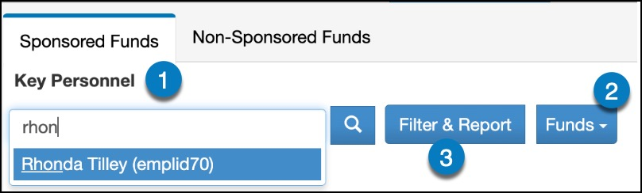
- Key Personnel: To select Funds to be displayed based on who the Responsible Person (PI or Financially Responsible) Type at least the first three characters of their first or last name in the Key Personnel Field and select the magnifying glass.
- Funds: This box allows you to select how you want to view the data you filtered on. The Results can be shown in 4 ways with any of the data selected in Key Personnel and the Filter and Report. You can see a list of:
  - Fund Codes
  - Cost Center Codes
  - Transactions rolled up at the RefNum1/RefNum2 combination lev
  - Individual Transactions
- Filter & Report: This will open a modal with a variety of fields you can select on multiple tabs to filter on for the results displayed.
  - Filters can be combined on different tabs to limit the data into the specific results you want to see.
  - For example, select Fund Types = Federal and Status = Active to see a list of only Active Federal Awards.
  - More than one may be selected in all of the master data table filters that say Please Select a Value (such as Fund code) except for the Fund Org Code and Trx Org Code fields.
  - Fields that are blank are free text fields where data can be entered to be searched by.
  - Once all results have been selected, click on the Search button at the bottom right to view the data results.
  - Save any of the Filter criteria and name the saved search by entering a name in the Save Search Criteria as field and then clicking Save. Saved flyers can be retrieved that in the Saved tab.
General Tab
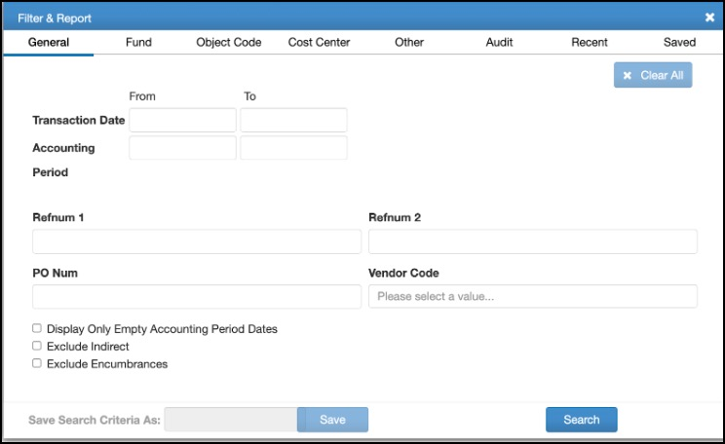
Fund
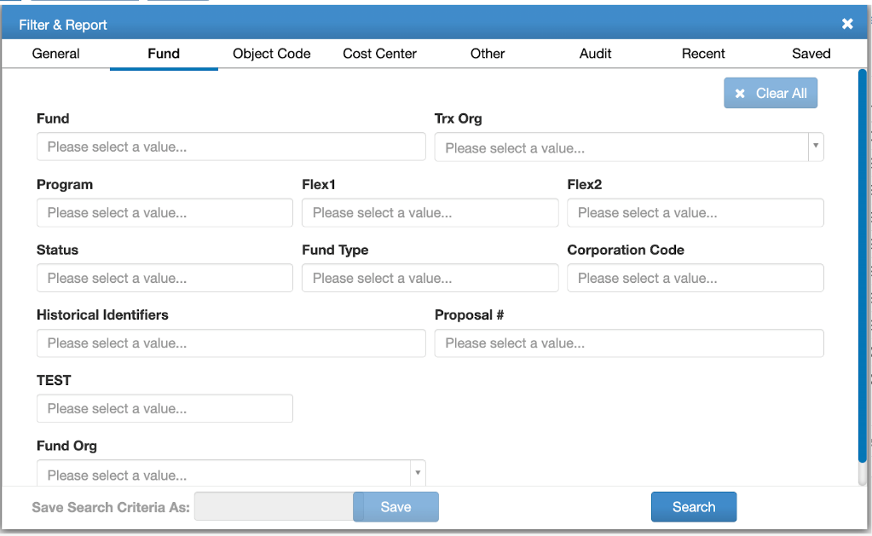
Object Code
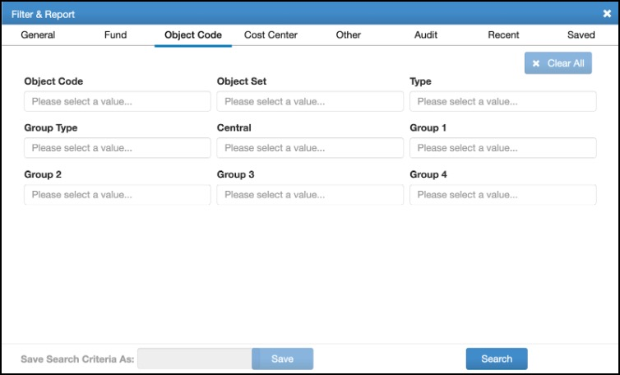
Cost Center
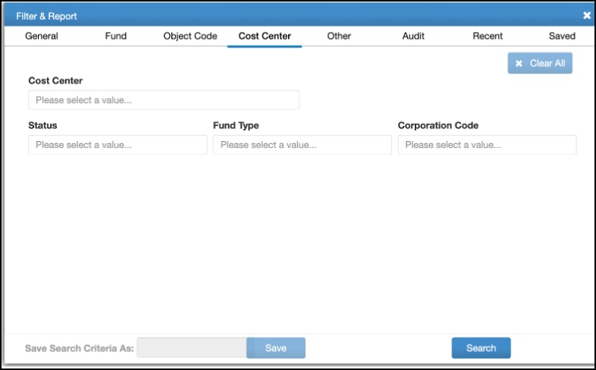
Other
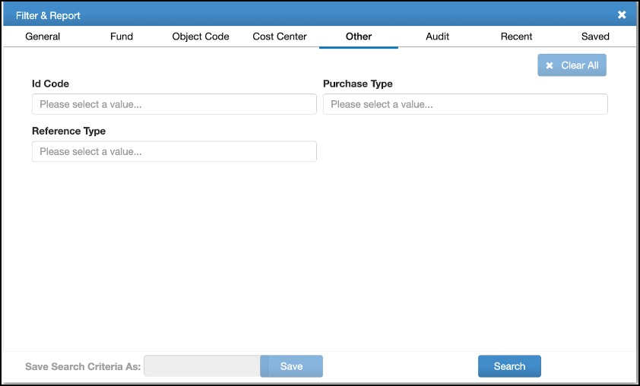
Audit
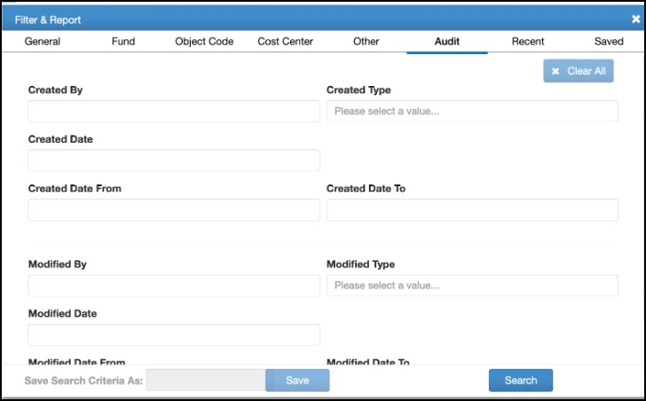
Recent
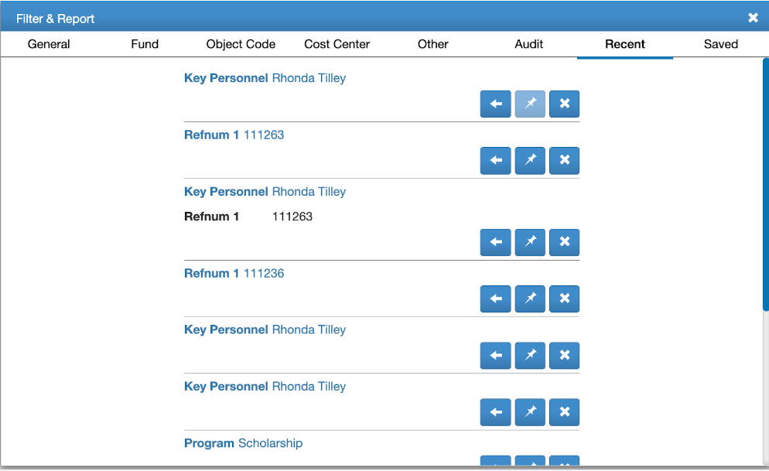
Drilling Down Into a Fund
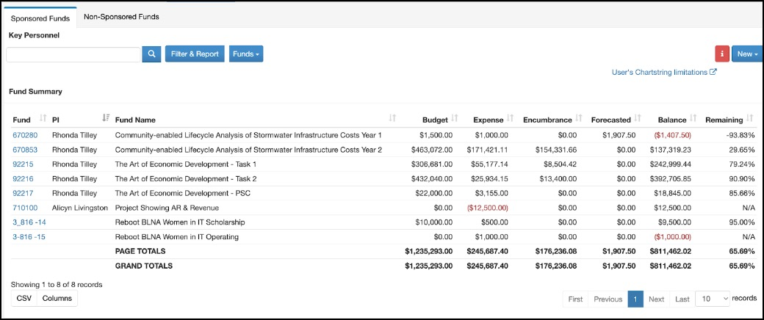
Select the Fund to take you to the Fund Balance By Object Code Summary Page.
The first box shows general Fund information
The second box shows the Balances to Date.
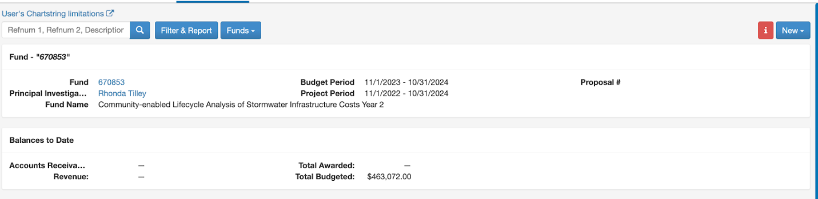
The third box shows the balances broken down by the Object Code Groups. There are two ways to view this data.
The Separate IDC Tab view:
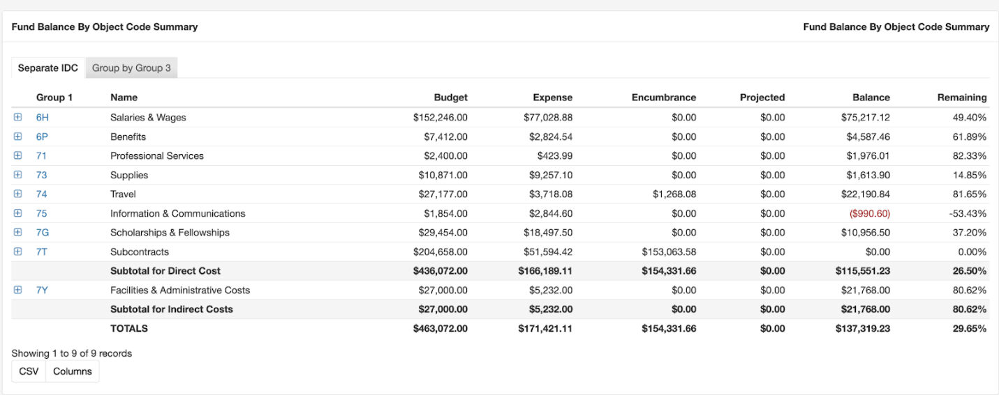
Group by Group 3 view:
