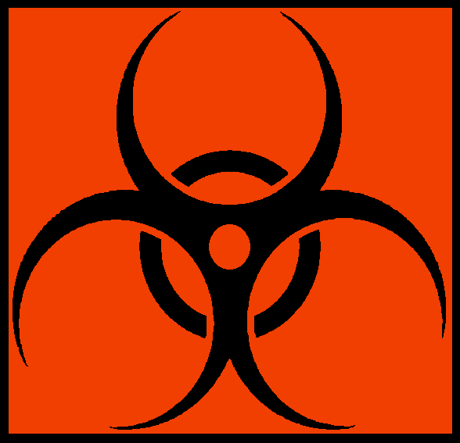
BIOHAZARD

Biological Agents Present:
Biosafety Level:
Lab Emergency Contact:
Contact Office Location:
Contact Phone Number:
After Hours Phone Number:
Safety Officer: Austin Hoffman (304) 412-5788

Instructions

Complete the biohazard agent(s) and contact information, then post sign on the outside of the laboratory door to make emergency responders aware of the hazards inside the room. Update as needed, when contact person or biohazard agent(s) change.

Contact Safety & Health, 6-3461, with questions.

