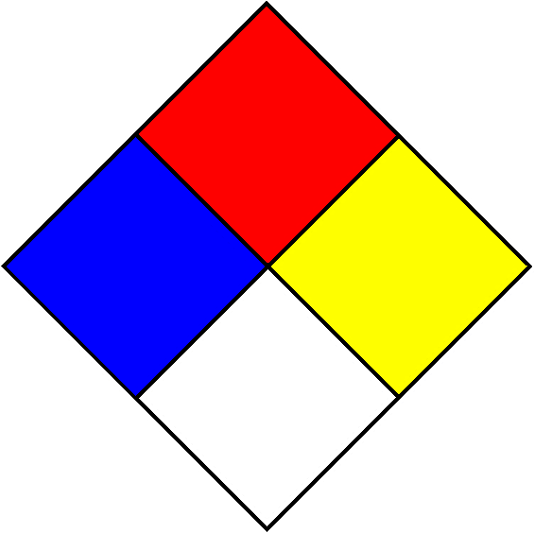
HAZARDOUS MATERIALS
Lab Emergency Contact:
Contact Office Location:
Contact Phone Number:
After Hours Phone Number:
Safety Officer: Bertha Akagbue (681) 306-5427
HAZARDOUS MATERIALS
Lab Emergency Contact:
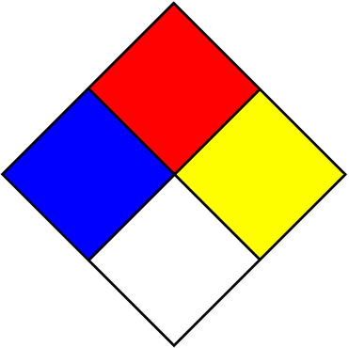 | 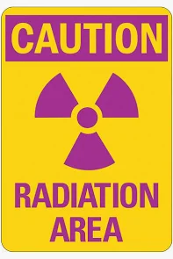
Contact Office Location:
Contact Phone Number:
After Hours Phone Number:
Safety Officer: Bertha Akagbue (681) 306-5427

HAZARDOUS MATERIALS
Lab Emergency Contact:
Contact Office Location:
Contact Phone Number:
After Hours Phone Number:
Safety Officer: Bertha Akagbue (681) 306-5427
Instructions
Pick one of the 3 templates that corresponds to the hazards that exist in your lab. If you do not use radioactive materials, then do not pick the second or third template etc. Complete the contact information, then post sign on the outside of all entrance doors to make emergency responders aware of the hazards inside the room. Update annually and as needed, when contact person or hazard ratings change. If you work with biohazardous material please post that signage as well.

Each block in the Hazard Diamond is rated on a scale of 0-4. The white block is for special hazards only:
W - for Water Reactive materials
OX - for Oxidizers
SA - for Simple Asphyxiant Gases in list below
(Nitrogen, Helium, Neon, Argon, Krypton, and Xenon)
The numbers posted should not be based on just one chemical. They should reflect the collective hazard of all of the chemicals stored in the room.
The hazard information can be obtained from the container label, the Safety Data Sheet (SDS), or from the manufacturer’s web site.
Contact Environmental Health & Safety with questions, 696-3461.
Below are text boxes you can copy/paste or drag to fill in the diamond above, and print a clean, legible sign:
W
OX
W
0

1
2
3
4
OX
SA
W
SA
OX
SA
W
OX SA

